1. Go to <https://console.cloud.google.com/apis/credentials>
2. Please note this may look a little different due to person google vs GSuite
3. Click Create Credentials  
     
   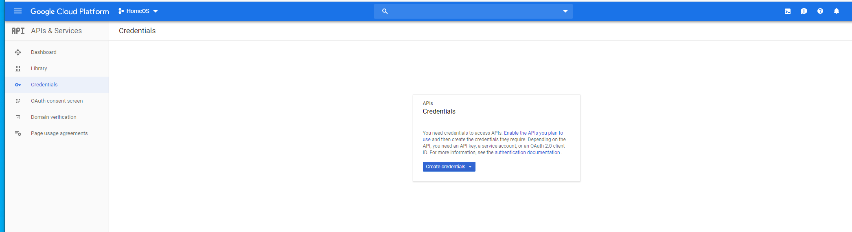
4. Go to OAuth Client ID  
     
   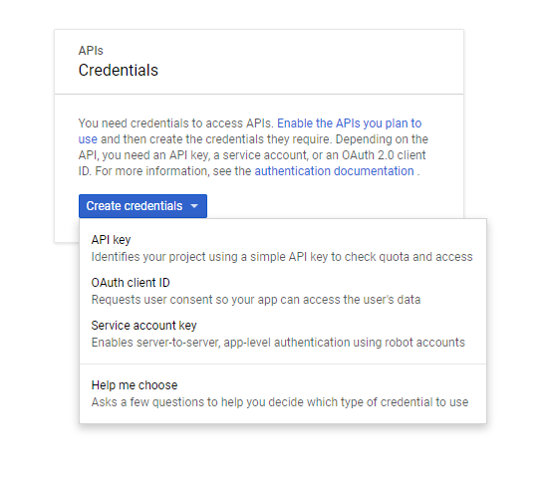
5. Configure Consent Screen  
     
     
     
   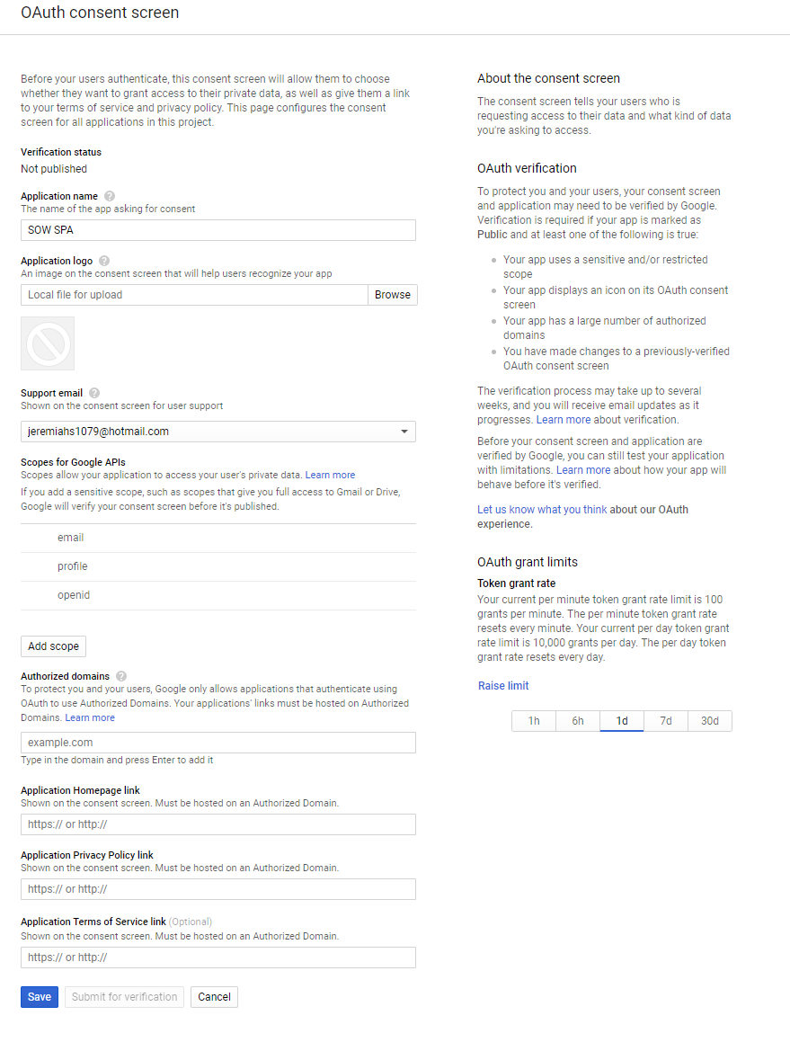
6. As far as I know the only required is the application name and support email. The default scopes are fine. Authorized domains would be @ms3-inc.com
7. Save
8. Create Web Application OAuth Client ID
9. The Authorized JavaScript is the link to the sow app. This should also go into Authorized redirect URI’s  
     
   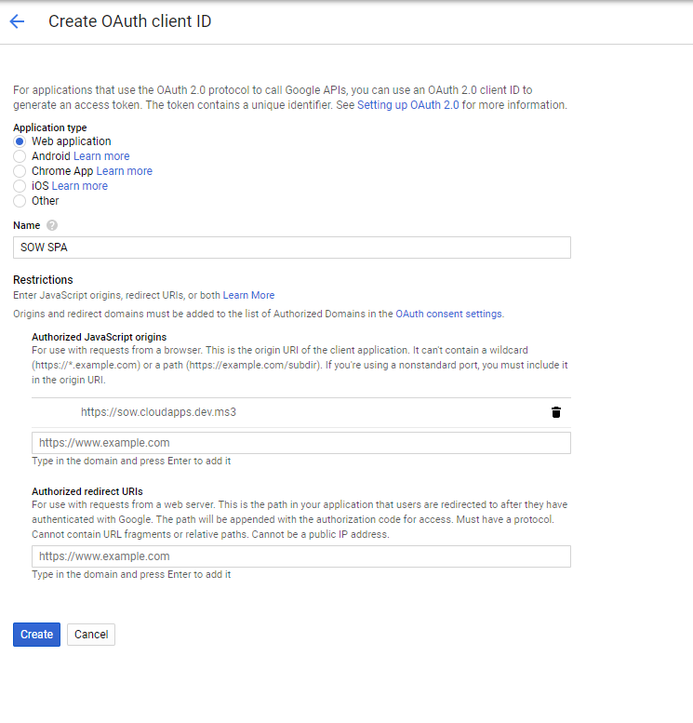
10. Record Client ID  
      
    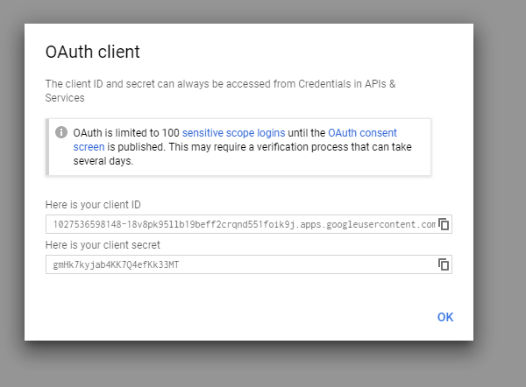
11. This will go into the sow environment file for prod and regular  
      
    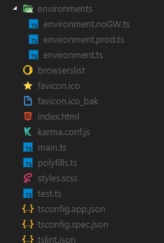
12. Done.